ACSL
American Computer Science League
2010 - 2011

Contest #4

Junior Division
Matrix Encryption

PROBLEM: One method of code encryption uses matrix multiplication. The letters of the alphabet are assigned the numbers 1 – 26 in order and a space is given a value of 27. Although at first glance this might seem a simple code to break, the beauty of the system is that once matrix multiplication is performed, it is very difficult to determine the encoding matrix. The encoding matrix is usually only known by the sender and the receiver. For this program a 2x2 encoding matrix will be used. The method to use is as follows:

1. Convert the message into a series of 2x1 matrices: Given the code MATH ROCKS. The matrices

formed will be as follows: 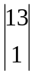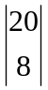 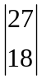 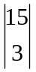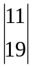. If the code has an odd number of letters the last character is considered to be a space (27).

2. Mutiply each matrix by the encoding matrix. For this example the encoding matrix is 0111 and it is read in across the rows of the 2 x 2 matrix as follows: 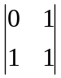.
* = 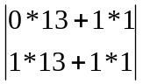= 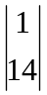. This procedure is repeated for each 2x1 matrix. To produce:

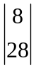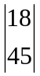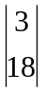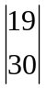

3. Convert each product back to alpha form. This is the message that gets sent. If the matrix contains a value greater than 27, then print the character MOD 27 of that value. The above produces ANHARRCRSC.

INPUT: There will be 5 lines of input. Each line will contain an alpha string and 4 positive integers representing the 2x2 encoding matrix to be entered across the rows.

OUTPUT: For each input line, print the resulting alpha string.

SAMPLE INPUT SAMPLE OUTPUT
- MATH ROCKS, 0,1,1,1 1. ANHARRCRSC
- COMPUTER, 1,1,3,2 2. RLBQNVWX

ACSL
American Computer Science League
2010 - 2011

Contest #4

Junior Division
Matrix Encryption
TEST DATA
TEST INPUT TEST OUTPUT

- COMPUTE, 3,2,1,1 1. LRQBVNOE
- ALL STAR, 3,4,2,3 2. XKIXBQUB
- ACSL, 5,2,2,1 3. KEKW
- RECURSIVE EXP, 1,0,2,1 4. RNC RAIMEJEGPE
- CLASS A BASEBALL,2,1,1,1 5. ROUTKSBAECPXECIX

